**Drone Olympics Challenges**

For the last day of camp, we have created six challenges that will test a variety of topics covered in this course. Read the description of each challenge to understand what you are being asked to do. Then, you can read each challenge’s listed scenario to understand how drones are used in real life to solve problems. Once you have read through the available challenges, work with your group to complete as many of them as you can.

**Challenge 1: Search and Rescue**

**Objective:** Program the drone to navigate through a series of hula hoops using sequential instructions.

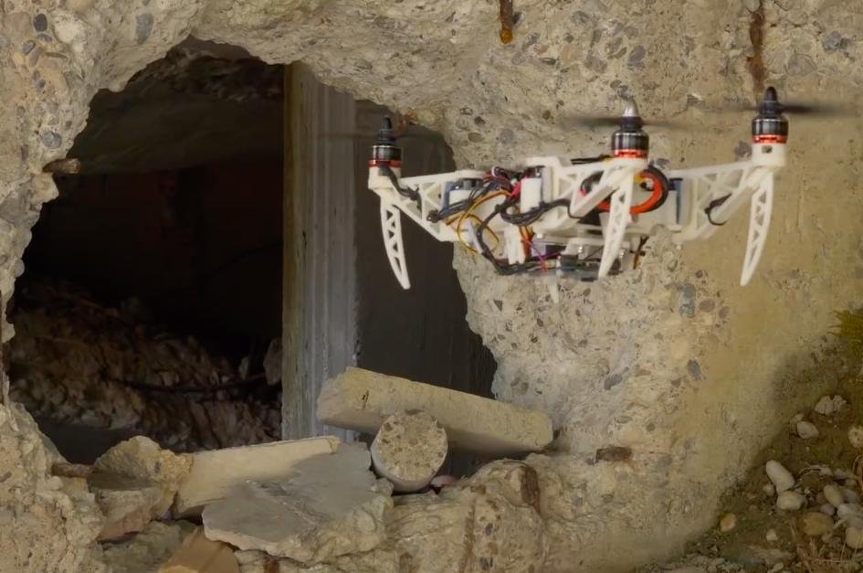

**Scenario:** Your drone is needed to help people escape a collapsed mine. Tourists went to explore an old mine, but while they were in there, rocks started to fall, and their way out became blocked. There are narrow pathways above the ground that could be used to escape. In order to ensure the path is safe, your drone needs to fly through the narrow openings.

**Key Concepts:** Sequential Programming, Loops, Measurement

**Instructions:**

1. Set up multiple hula hoops at different locations in the area.
2. Define a sequence of instructions for the drone, such as ascending, flying forward, turning left/right, and descending.
3. Write a program to guide the drone through the hoops by executing the instructions in the specified sequence.
4. Use loops to repeat the instructions and track the drone's progress.
5. Test the program and adjust as needed to ensure the drone successfully traverses through each hula hoop in the correct order.

**Search and Rescue SOLUTION**

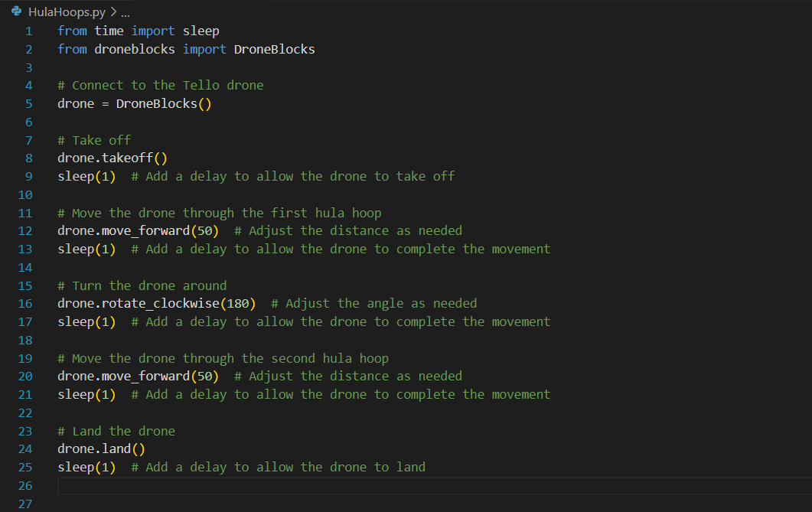

**Challenge 2: Maze Navigation**

**Objective:** Program the Tello drone to navigate through a maze using sequential commands.

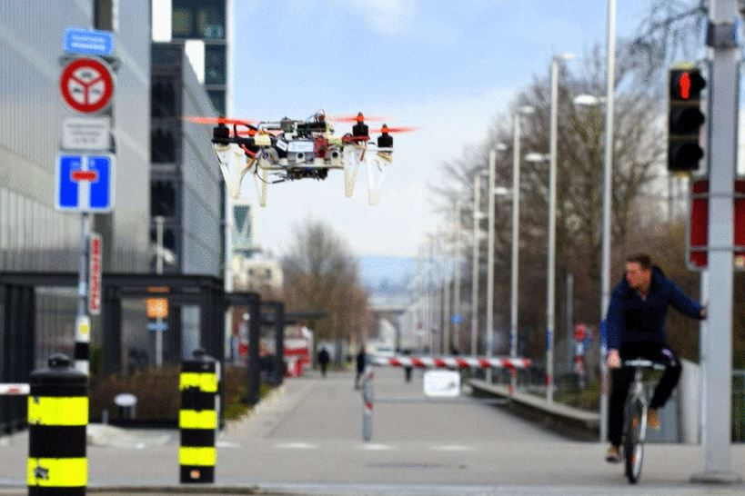

**Scenario:** Your drone is responsible for helping a confused driver navigate through a winding city. Because of the abundance of turns and dead ends, it is easy to get lost. You have to be able to find your way out of the maze in a timely and efficient manner.

**Key Concepts:** Functions, Sequential Programming, Measurement

**Instructions:**

1. Connect to the Tello drone using the provided DroneBlocks library and establish the connection.
2. Design a maze layout with clear paths and obstacles to create a challenging navigation task.
3. Implement the navigate_maze() function to define the drone's movements through the maze.
4. Customize the distances and angles within the function to match your maze layout.
5. Use the move_forward() command to make the drone move forward a specific distance.
6. Use the rotate_counter_clockwise() and rotate_clockwise() commands to make the drone turn left or right at specific angles.
7. Add appropriate sleep() statements to introduce delays after each movement to ensure the drone completes the action before proceeding to the next one.
8. Test the program by running the maze navigation function with the Tello drone.
9. Observe and adjust the distances, angles, and delays as needed to successfully navigate the maze.

**Maze Navigation SOLUTION**

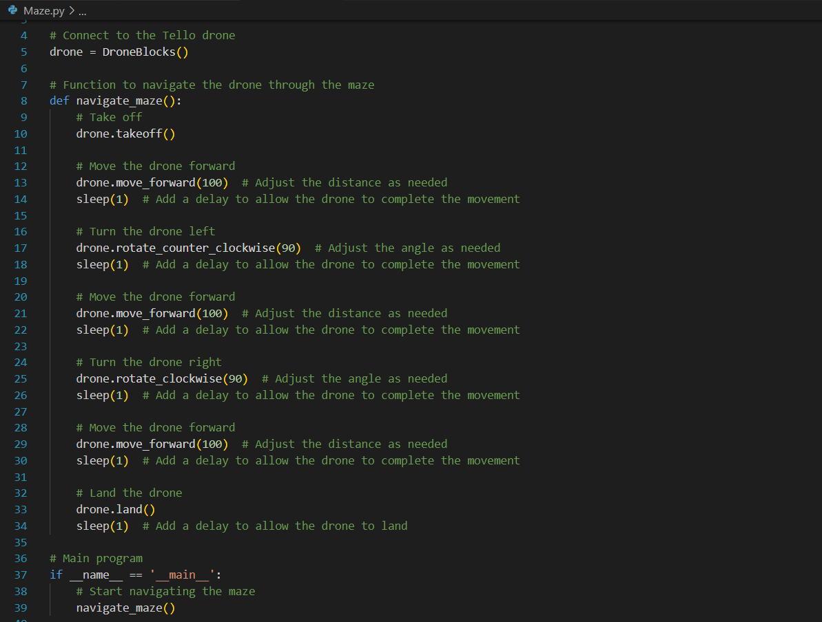

**Challenge 3: Day in life of a Civil Engineer**

**Objective:** Program the drone to visit mission pads in a specific order and perform actions based on their identifiers.

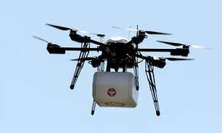

**Scenario:** You are Civil Engineer; suppose you have been given a contract of calculating how high you can build a building. For this, including multiple others factors you need to calculate the area of the given land.

**Key Concepts:** Logic, Mission Pads

**Instructions:**

1. Set up multiple mission pads at different locations
2. Write a program that instructs the drone to visit the mission pads in a specific order.
3. Use sensors to detect the mission pads and read their identifiers.
4. Implement conditional statements to check if the drone has reached the correct mission pad based on its identifier.
5. Calculate the area of the shapes.
6. Test the program by running the drone through the mission pads, ensuring it visits them in the correct order and performs the designated actions.

**Challenge 4: Relay Race**

**Objective:** Work and communicate with a team to complete unique tasks.

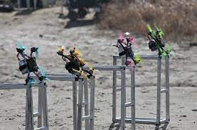

**Scenario:** Work with your team to show off what you have learned.

**Key Concepts:** Flips, Logic, LED Control, Collaboration

**Description:** Students’ drones will take turns flying to mission pads. At each mission pad, the drone will be expected to complete a task.

**Instructions:**

1. Set up a starting area for the team.
2. Place down a mission pad for however many people are in each group. Some obstacles can be placed in the way of mission pads.
3. The first member of the team will have to do a flip and land for 3 seconds before returning to the starting point.
4. When the first drone lands at the starting point, the second drone can start its mission.
5. When the second drone gets to the mission pad, it must take a 360-degree video before it returns to the starting point (Recommend using block coding to take the video).
6. Once the second drone returns, the third drone can begin its mission.
7. When the third drone gets to its mission pad, it can do 3 things dependent on its battery percentage.
   1. If the percentage is above 60%, make the LED display an animation. Once the animation is over, show a smiley face and return to the start
   2. If the percentage is between 60%-30%, make the LED display a scrolling message. Once the message is over, display a straight face and return to start.
   3. If the percentage is below 30%, make the LED display a sad face and have it return to the start.
8. Once the final drone returns, the mission is complete.

**Relay Race SOLUTIONS**

**Code for Person 1:**

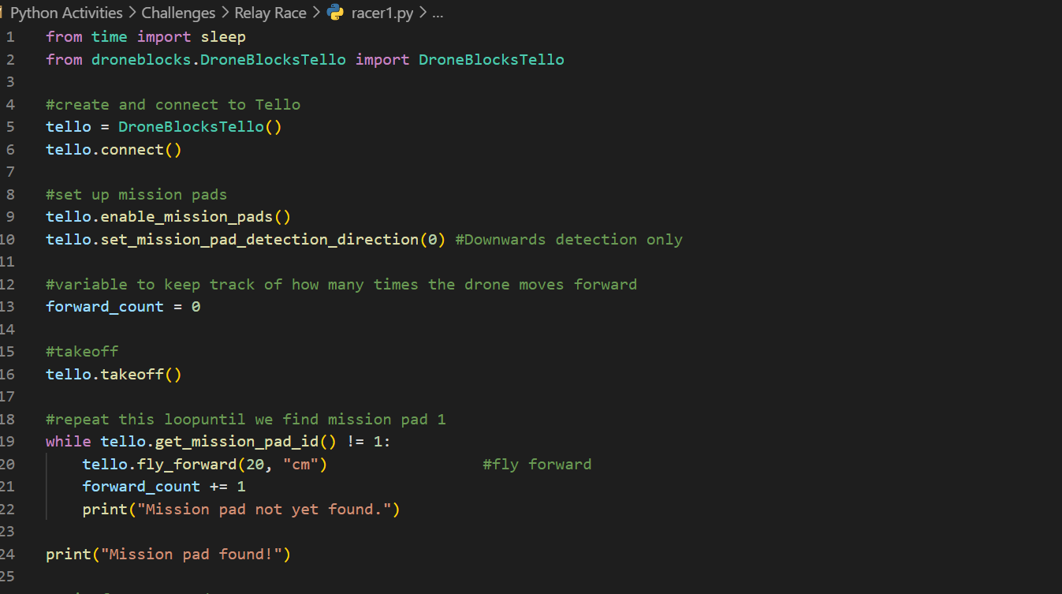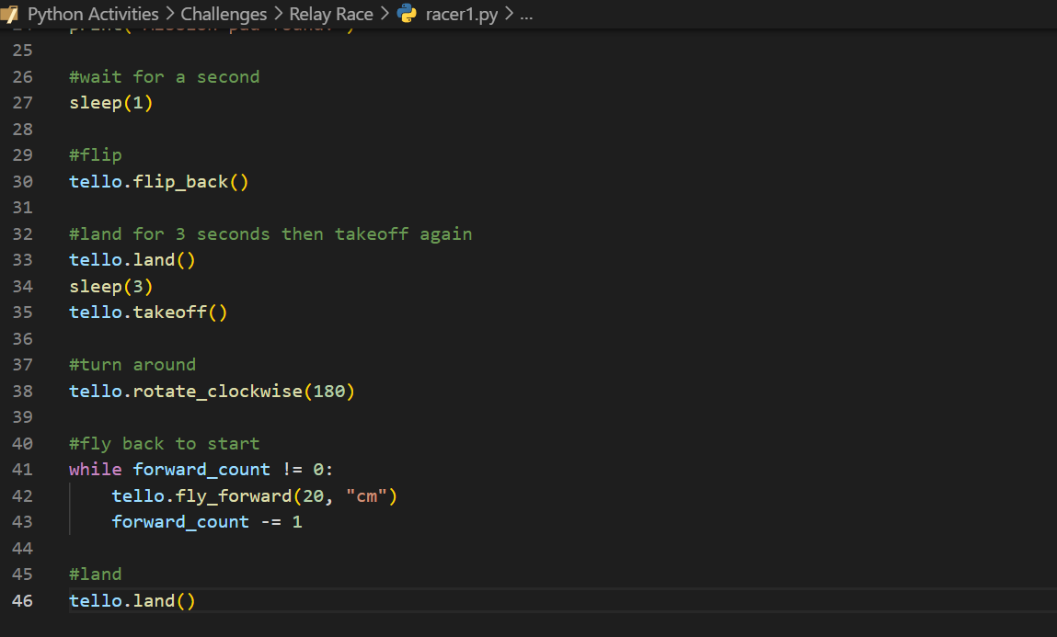

**Code for Person 2:**

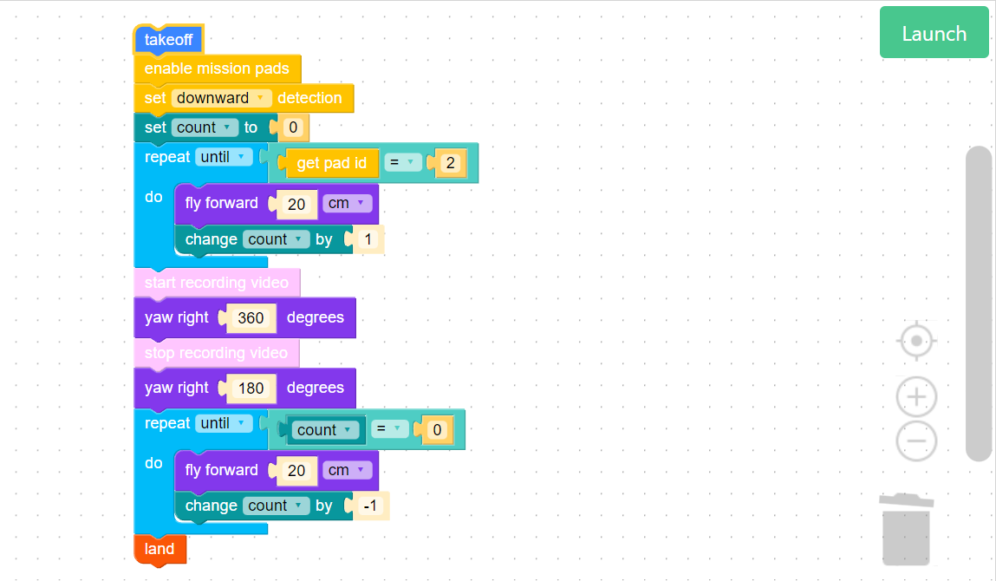

**Code for Person 3:**

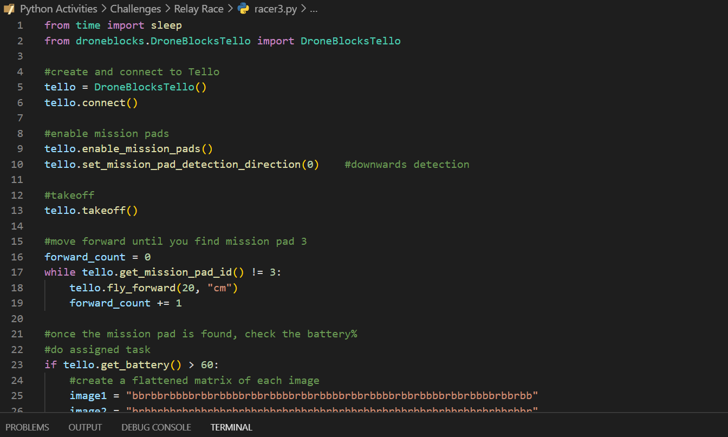

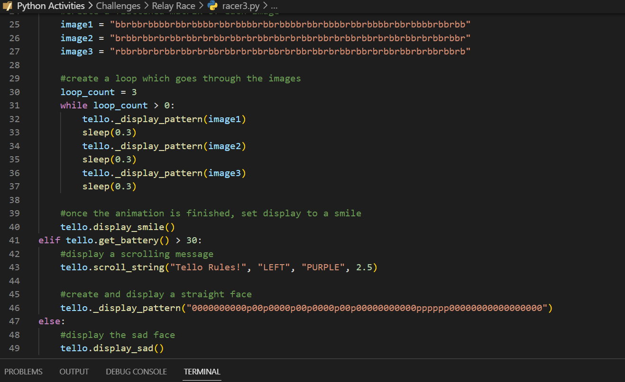

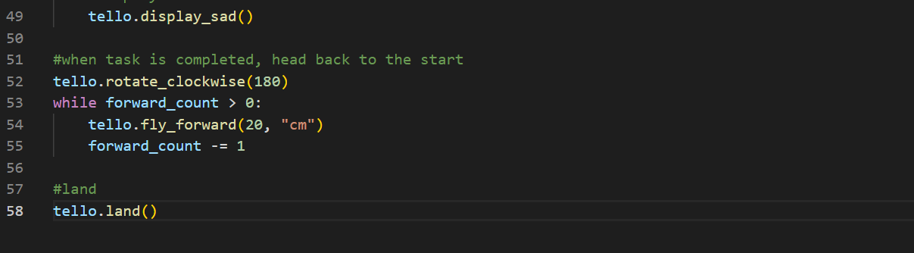

**Challenge 5: Dance**

**Objective:** Make a drone “dance” on-tempo in the air for 60-90 seconds.

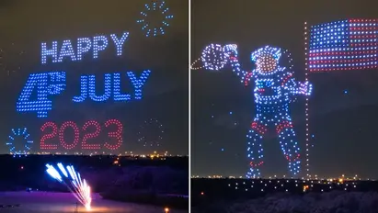 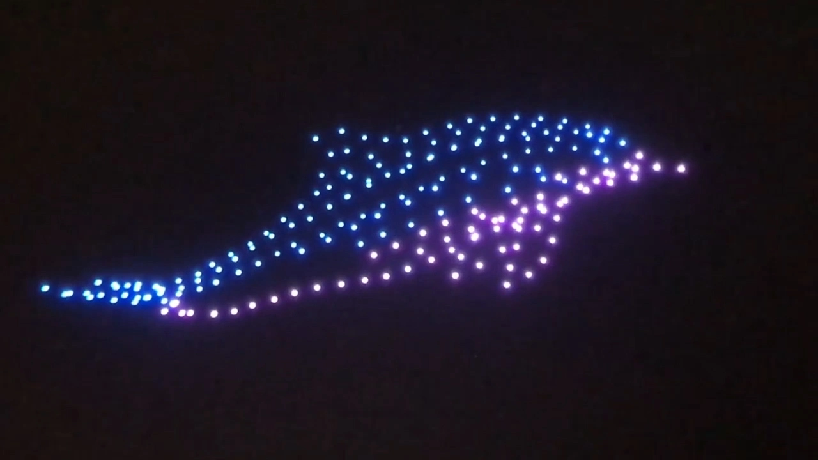

**Scenario:** You have been asked to put on a drone show as the opening act to a concert. In order to engage the audience, your drone’s movements should match the tempo of your chosen song. To make the show interesting, consider working with others or using the drone’s LED.

**Key Concepts:** Synchronization, Timing, Battery Control

**Description:** Participants will choose a song for their drone to dance to. They can find the BPM of their chosen song to help their dance. They can use turns, flips, or any type of movement to create the dance.

**Bonuses:**

1. Participants can use multiple drones and synchronize their actions.
2. Participants can use their 8x8 LED display to enhance their performance

**Instructions:**

1. Groups must find a song clip they will use (CHOOSE AN APPROPRIATE SONG).
2. Groups must find the beats per minute of the song which will help them choreograph their dance (easiest just to look this up).
3. Record data for the time it takes the Tello to execute each command.
4. Experiment with different types of movement to see what matches the music the best.

**Dance SOLUTION**

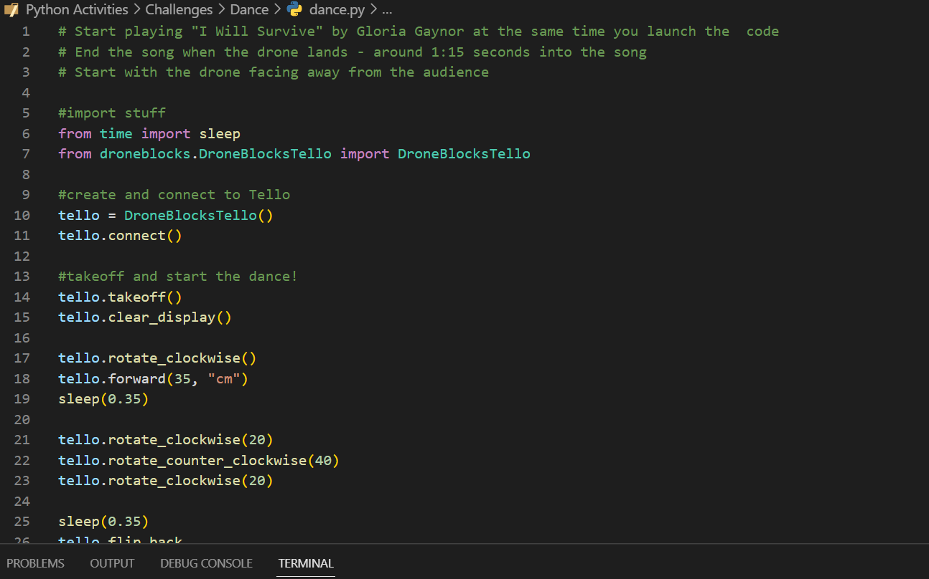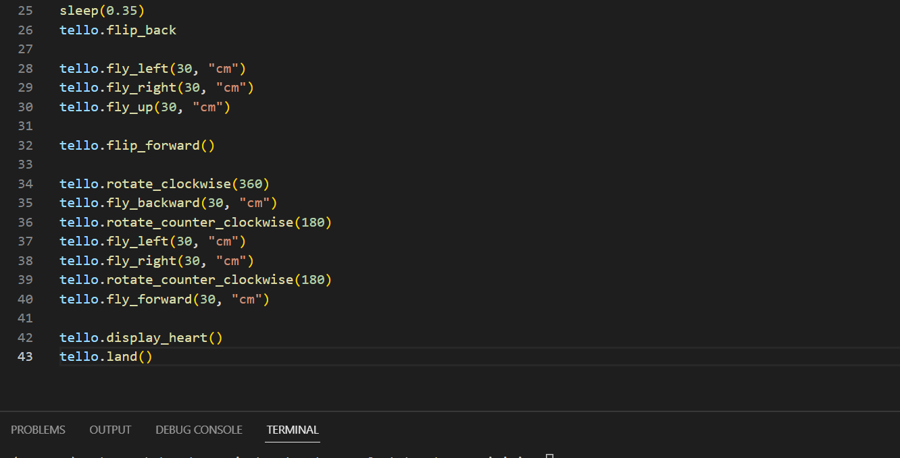

**Challenge 6: Advanced Simulator**

**Objective:** Complete the advanced simulator challenges.

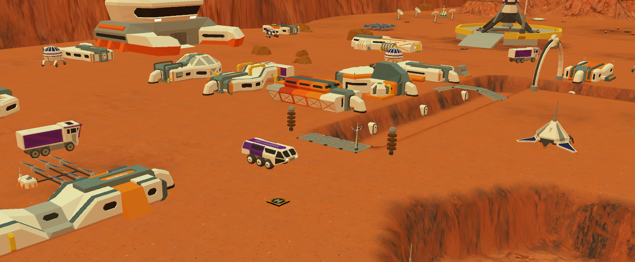

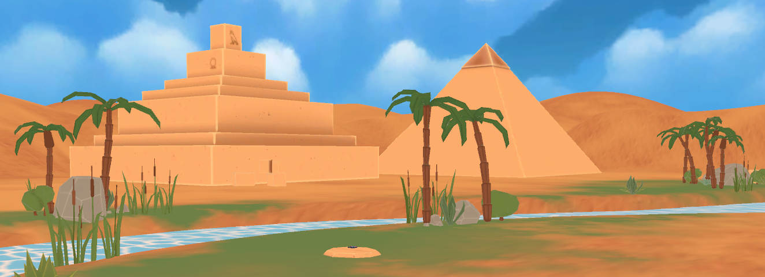

**Scenario:** You are one of the first researchers on Mars. You will use your drone to complete tasks that people are unable to do on another planet.

**Key Concepts:**

1. Surface Area – Functions, Math , Loops
2. Big Mars City Life – Functions, Flips
3. Rocket Science – Camera, Loops, Functions, Curves

**Description:** Work on the advanced simulator challenges in the Welcome to Mars, and the Egyptian Expedition missions. These lessons can be lessons 5-7 of the Mars mission.

**Instructions:**

1. Introduce the lessons from the DroneBlocks videos.
2. Students can use the DroneBlocks simulator to complete these tasks.
3. Compare the students’ answers with the solutions given.